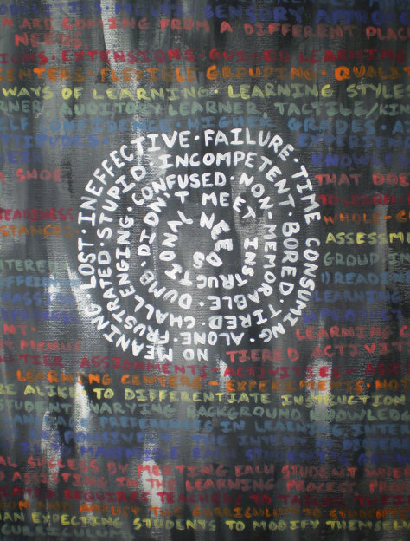

Figure 3. This student used writing combined with paint on canvas.

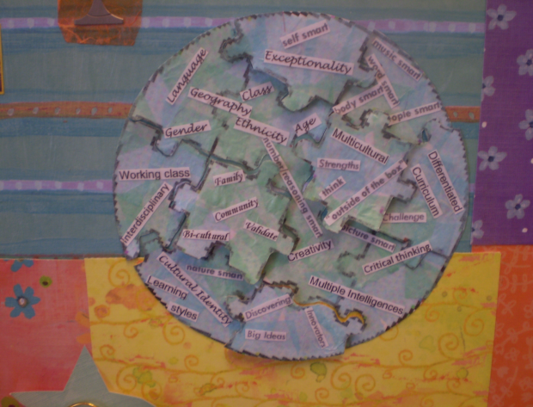

Figure 4. This section of an aesthetic representation combines 3 dimensional mixed media with text.

